ER Diagram
The system as built on branch mini-erp (Version 2.0): the three changes (Purchase Logic Draft2, QT Upgrade 2.0, User Version 2.0) are in. This replaces the older single-version description.
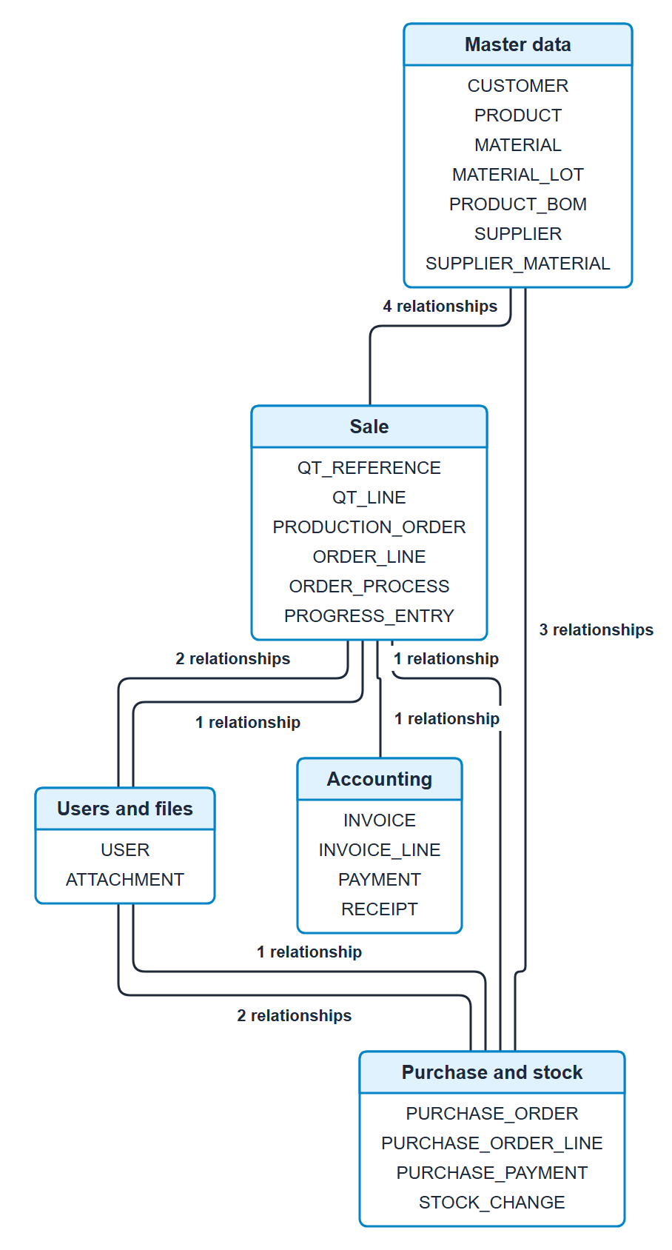
Figure 1. The 23 tables in 5 groups, and the relationships between the groups
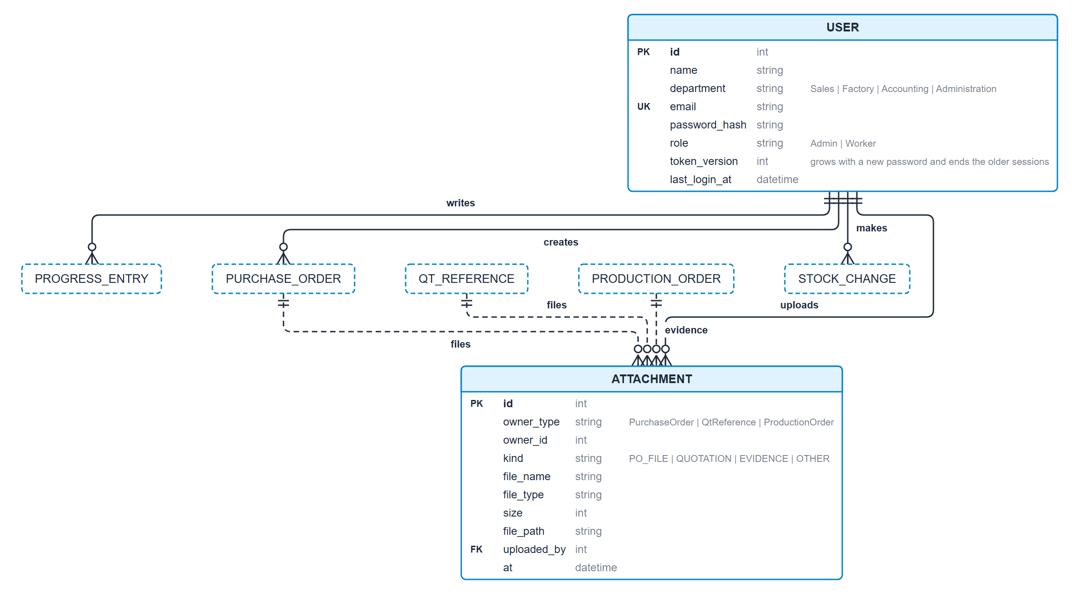
Figure 2. Users and files
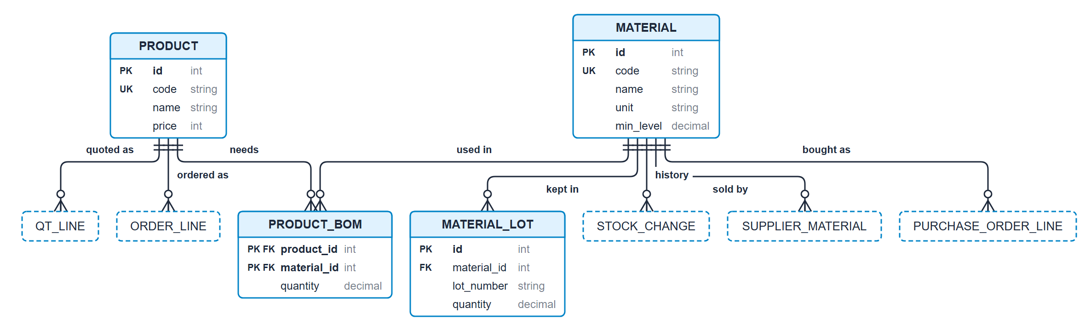
Figure 3. Master data: products and materials
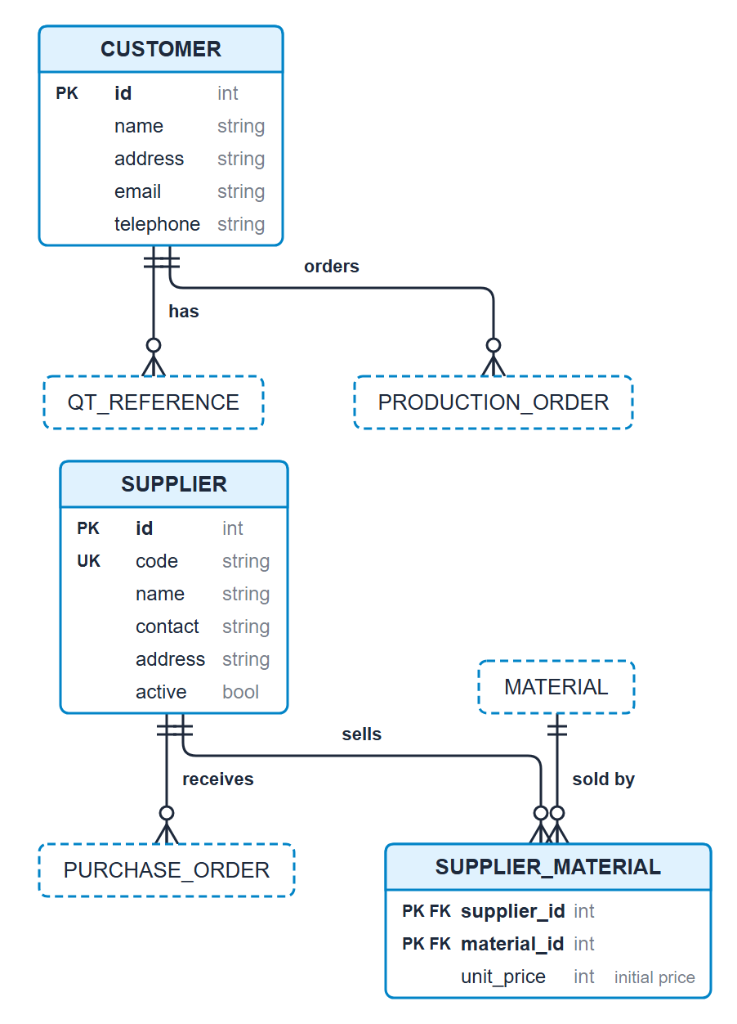
Figure 4. Master data: customers and suppliers
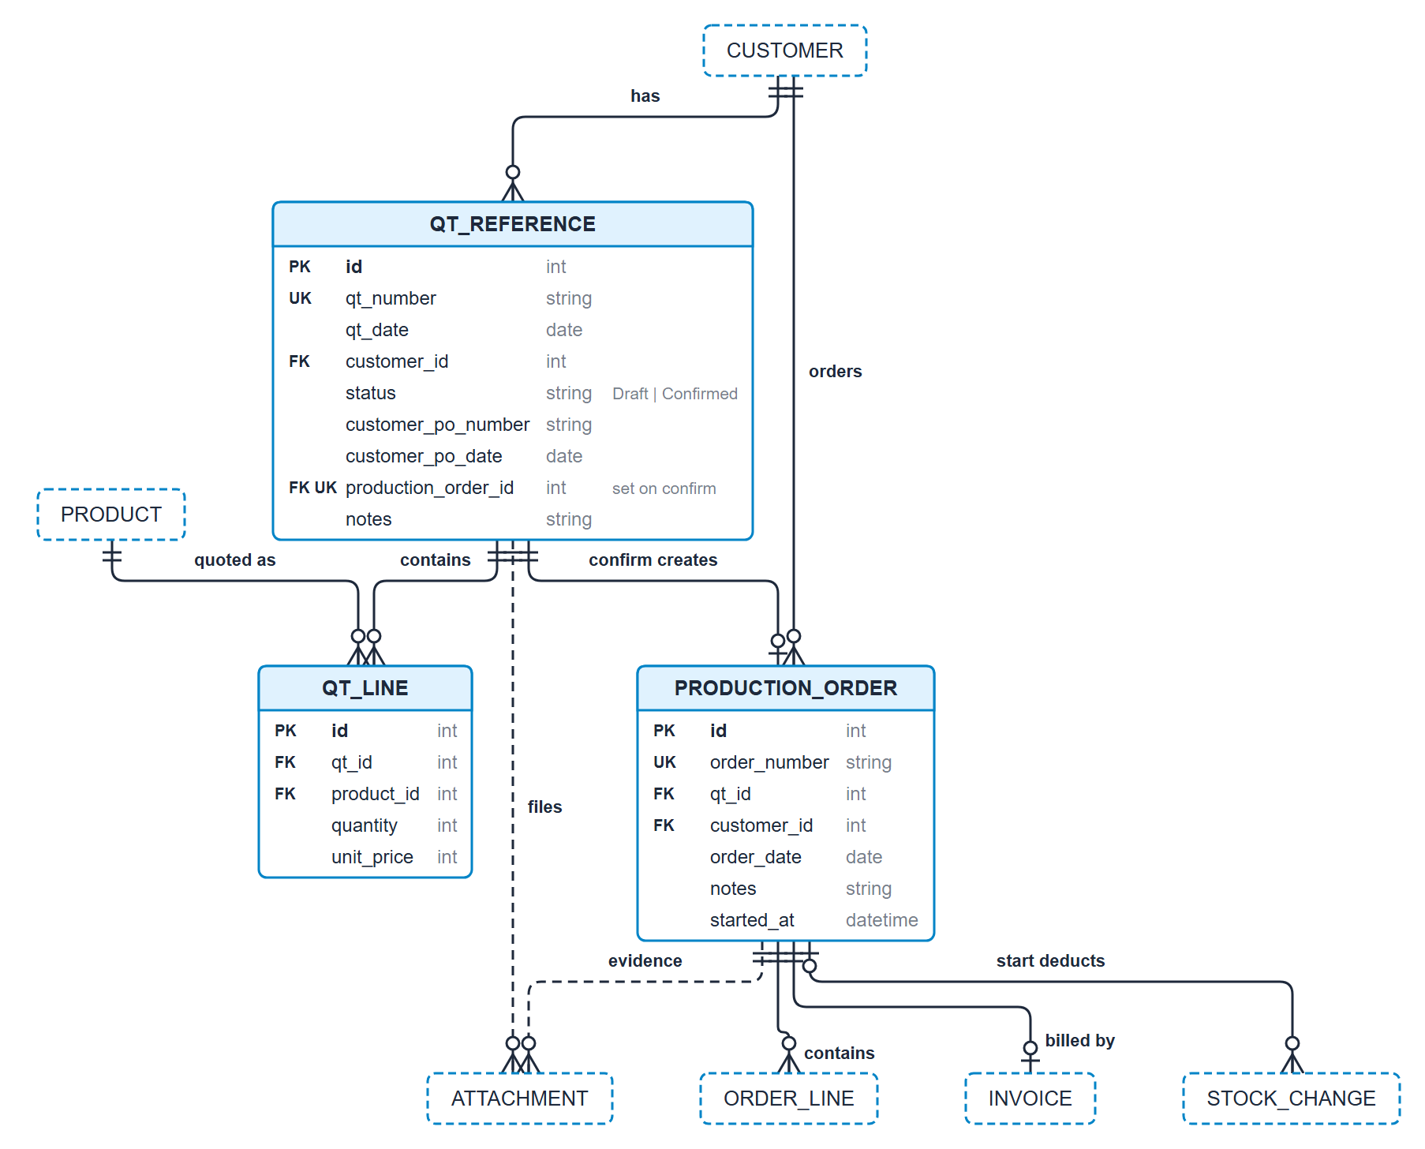
Figure 5. Sale: quotation
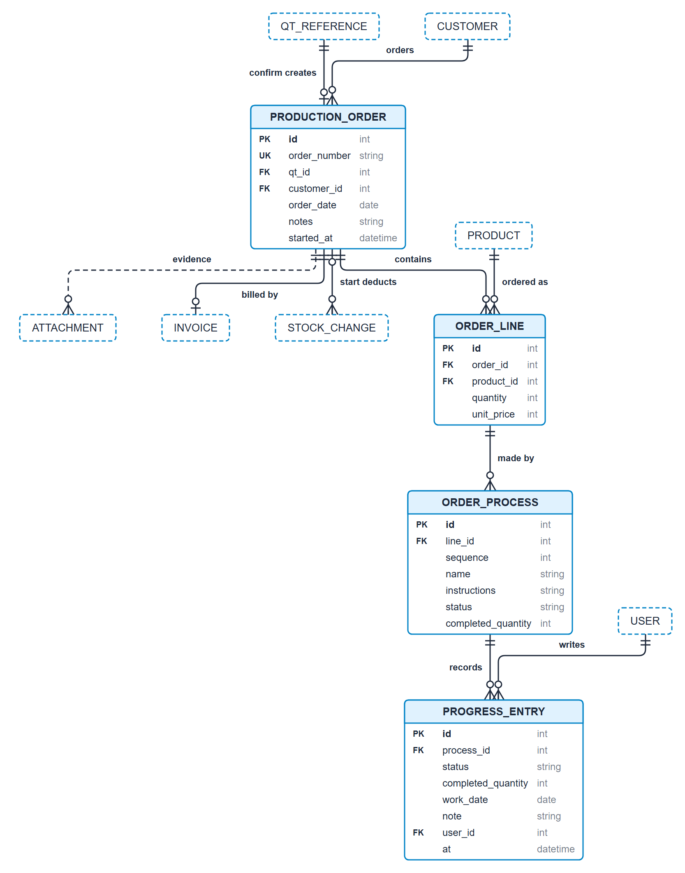
Figure 6. Sale: production order
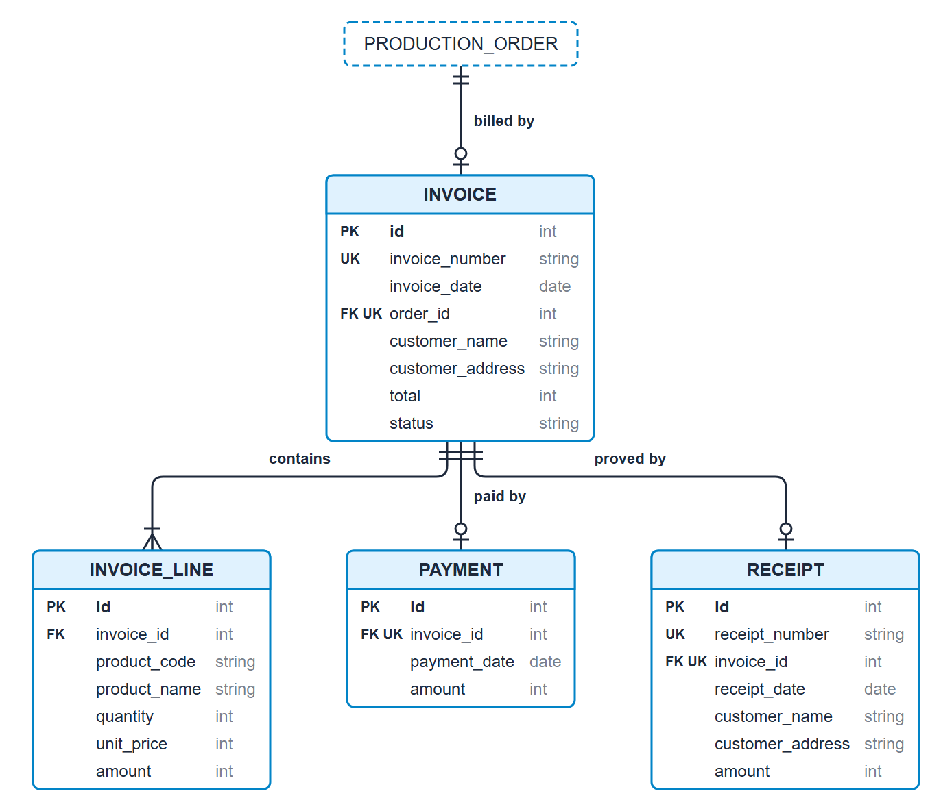
Figure 7. Accounting
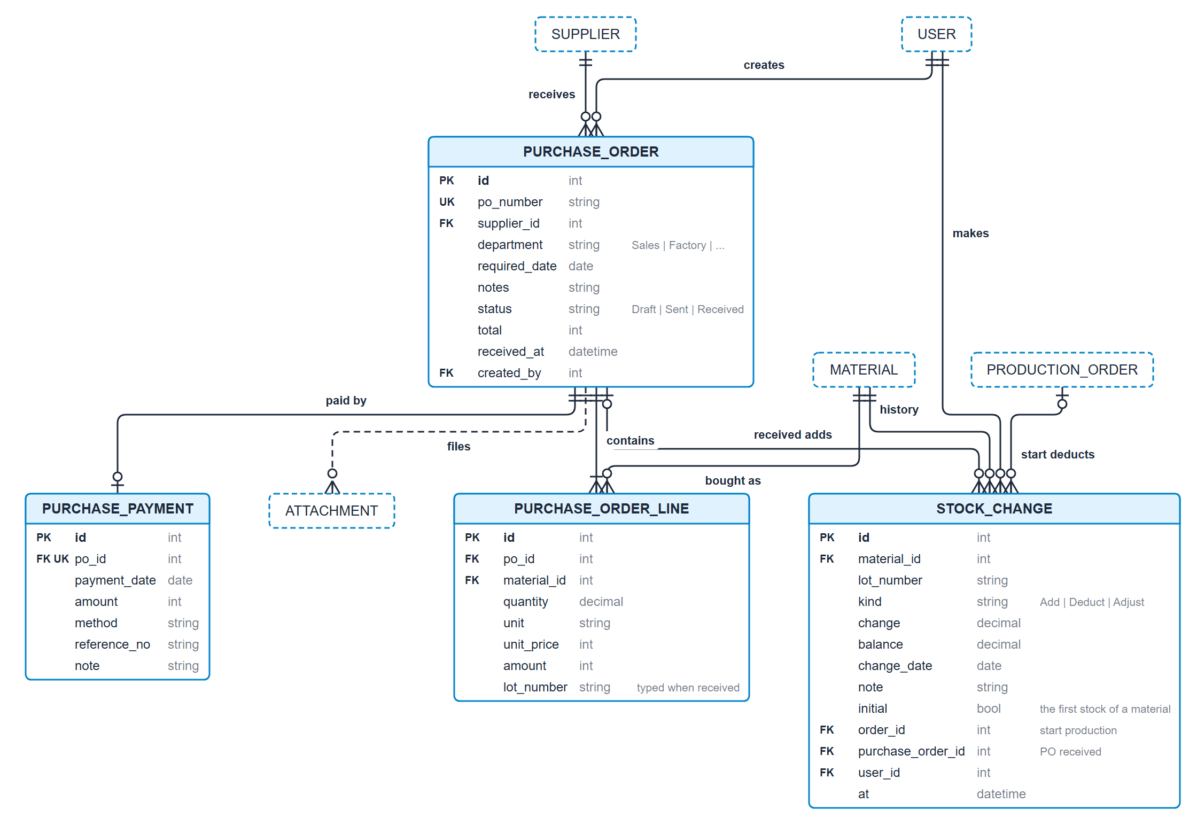
Figure 8. Purchase and stock

What Version 2.0 added
Source | Change
Purchase | New tables Supplier, SupplierMaterial, PurchaseOrder, PurchaseOrderLine, PurchasePayment. StockChange.purchase_order_id links a received PO to the stock it added
QT 2.0 | QtReference gets status, customer_po_number, customer_po_date, production_order_id. New QtLine. The old QT file and the customer PO file move to Attachment
Files | New Attachment table, shared by PO, QT and production order (evidence). Replaces file_name, file_type, file_path on QtReference
User 2.0 | No new column. A Worker's department must be Sales or Factory and decides access
Material | unit added (the PO lines need a unit)

Notes
- Attachment is polymorphic (owner_type + owner_id), so there is no database foreign key to the owner; the service checks it.
- PurchasePayment is stored on the PO and does not go through the Accounting tables.
- QT_REFERENCE.production_order_id is unique: one QT creates one Factory Order. It is the second link between the two tables, in the other direction of "confirm creates" (ProductionOrder.qt_id).
- QtLine has no stored amount: quantity x unit_price is computed by the API. The process, progress and invoice line tables list the columns the code has.
- Order status (Draft, In Progress, Completed) is computed from the processes; it is not a column. The stock status (Normal, Low, Out) is computed from the lot totals and min_level.
- Invoice and Receipt copy the customer and the product data when they are issued (a snapshot). An order is billed once, and an invoice has at most one payment and one receipt.
- An order is made only by Confirm QT, so ProductionOrder.qt_id is always set and each QT has at most one order.
- A QT, an order and an order line may have no line or no process for a while (zero or many in the database): the first QT line is required when the QT is confirmed, and a line and a process on every line when the order starts. A purchase order and an invoice always have lines.
- StockChange.initial marks the first stock of a material; a material with a later change cannot be deleted.
- ProductBom and SupplierMaterial have a primary key of two columns (PK,FK on both).

